ADTA 5750: Applied Natural Language Processing
Thuan L Nguyen, PhD
Final Project

Conversational AI System: Implementation & Development
Team: CarToGo (group 6)
Team Members:
- Sonali Sabnam
- Sheba Rani Paladugu
- Rinal Shah
- Rejesh Anne
- Tao Xiong
- Akhila Uppula

PART IV: Conversational AI System: Implementation and Development (20 Points)
Based on the above system design, the student must develop the conversational AI system using GCP Dialogflow CX and document in detail every step along the process.
For each step, the student should document the following details:
(1): Describe in detail what they have done
(2): Capture related screenshots to illustrate what they have done, including work results after completing the step.

SUBMISSION REQUIREMENTS PART IV:

--) Submit an MS Word document, “ADTA_5750_final_project_system_development_report.docx,” that includes the details and screenshots of all steps of the process.
Answer:
Introduction:
As part of this project, we designed and developed a virtual agent using DialogFlowCX which can help a customer to book a car rental. This document outlines the details of the development and implementation of the virtual agent built by Group 6 called “CarToGo”.
Objective:
The objective of this document is to describe the steps taken to develop and implement the AI based conversational virtual agent “CarToGo” for booking car rentals. It aims to provide a seamless and efficient booking experience by automating the workflows to reduce human intervention.
Assumptions:
For the sake of simplicity, the below assumptions are made to design the chatbot.
- This system is serving the requests only in the DFW area.
- The cost and payment details are not integrated with the virtual agent now. It is assumed that the payment will be done by the customer at pickup at the location.
- Fuel Type for all cars is “Gas” only.
System Design:
- System Overview
The system is developed with a simplistic design, yet it can handle the complexities involved in booking a car rental. The system comprises of various components which are described in the below mentioned points.

- Flows
  - There is only one flow which is developed to build the CarToGo chatbot.
  - This flow has three sub flows which are:
    - Booking Confirmation
    - Booking Cancel
    - Booking Swap
  - With these flow(s) the system can handle the required functionalities to book a car rental.
  - The below diagram shows the flow which is used to design the system.
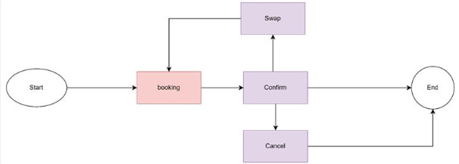
Figure: Flow of CarToGo
  - The below screenshots show the flows developed for the virtual chatbot. In the screenshots, we can also see the pages associated with each of the flow/sub flow.
  - Default Start Flow
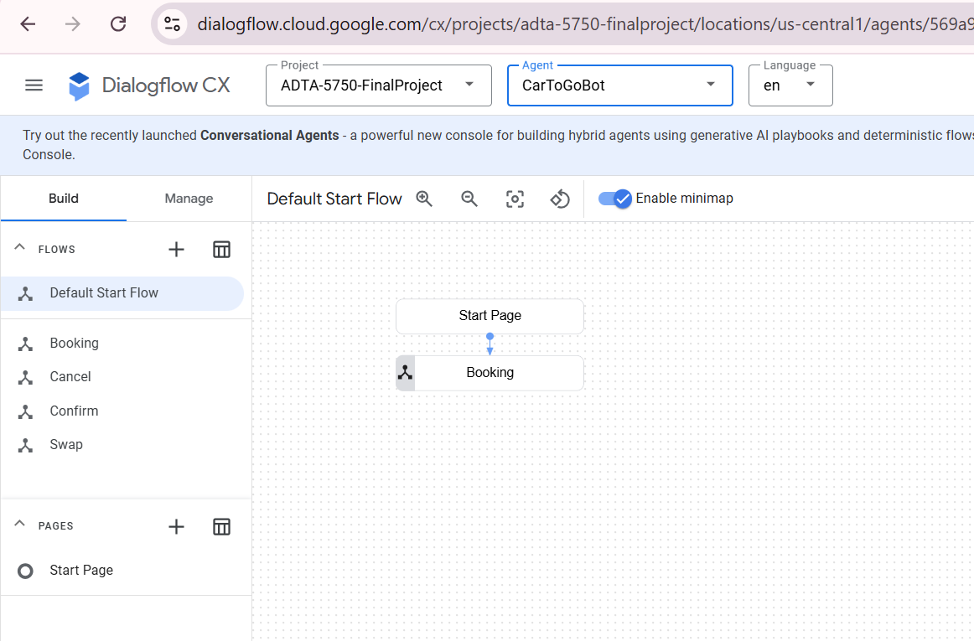
Figure: Default Start Flow
  - Booking Flow
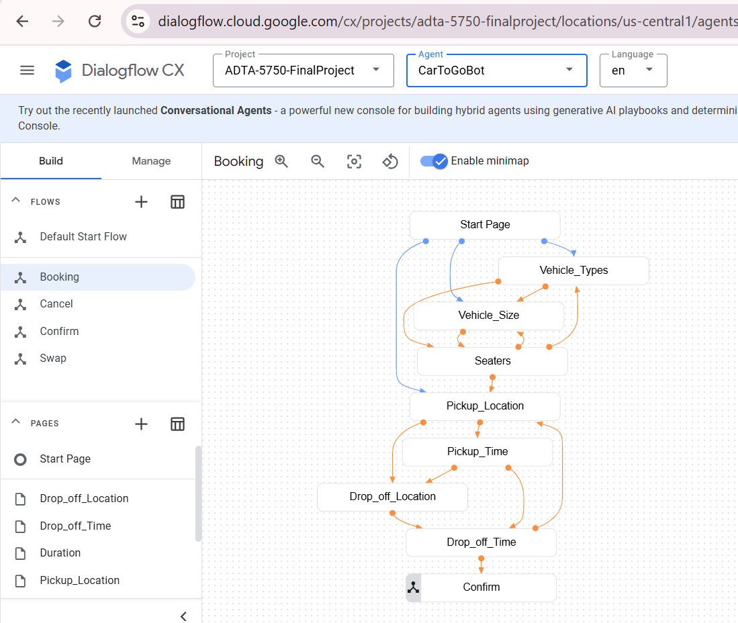
Figure: Booking flow
  - Cancel Flow
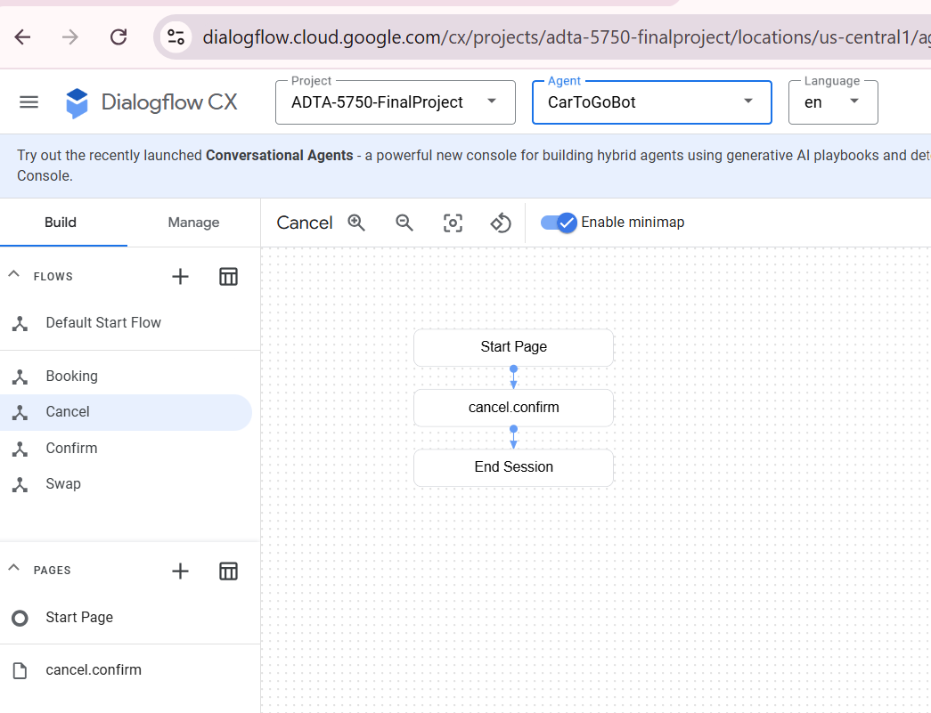
Figure: Cancel Flow
  - Confirm Flow
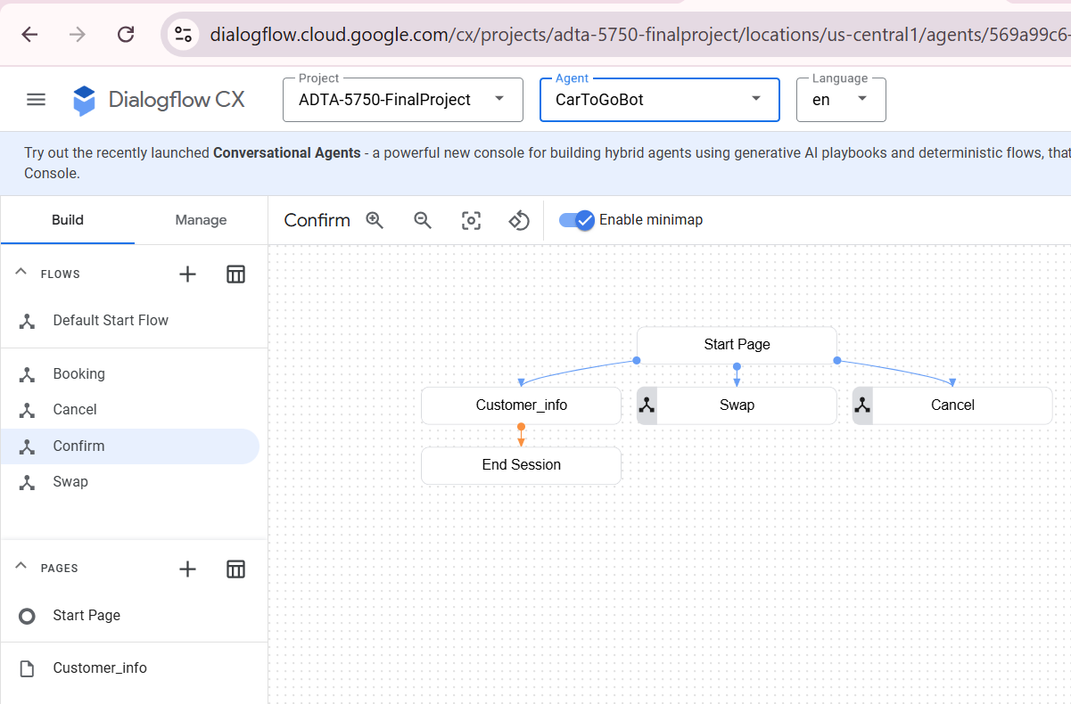
Figure: Confirm Flow
  - Swap Flow
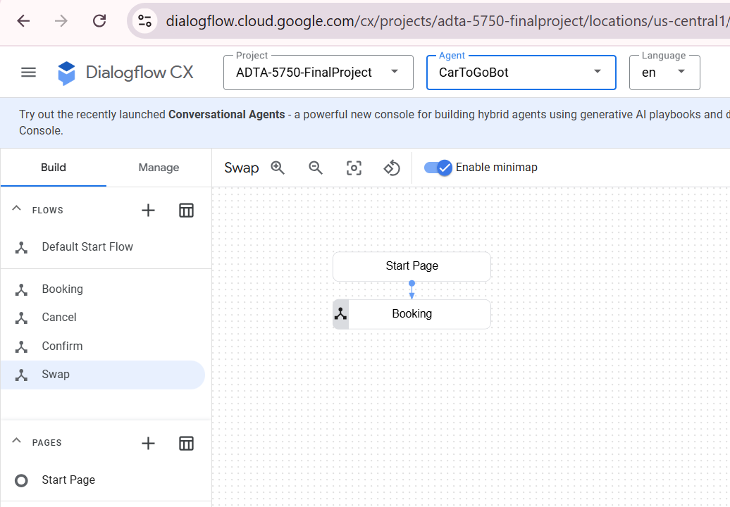
Figure: Swap Flow
- Entity Types:
  - There are four entity types used to develop the chatbot.
    - Drop_off_Location: the location where the car will be dropped.
    - Vehicle_Types: type of vehicle (Sedan, SUV, Van)
    - Vehicle_Sizes: the size of the vehicle (Compact, Standard, Full size, Premium)
    - Pickup_Location: the location where the vehicle is going to be picked up by the customer.
  - The below diagram shows the entity types developed for the virtual agent.
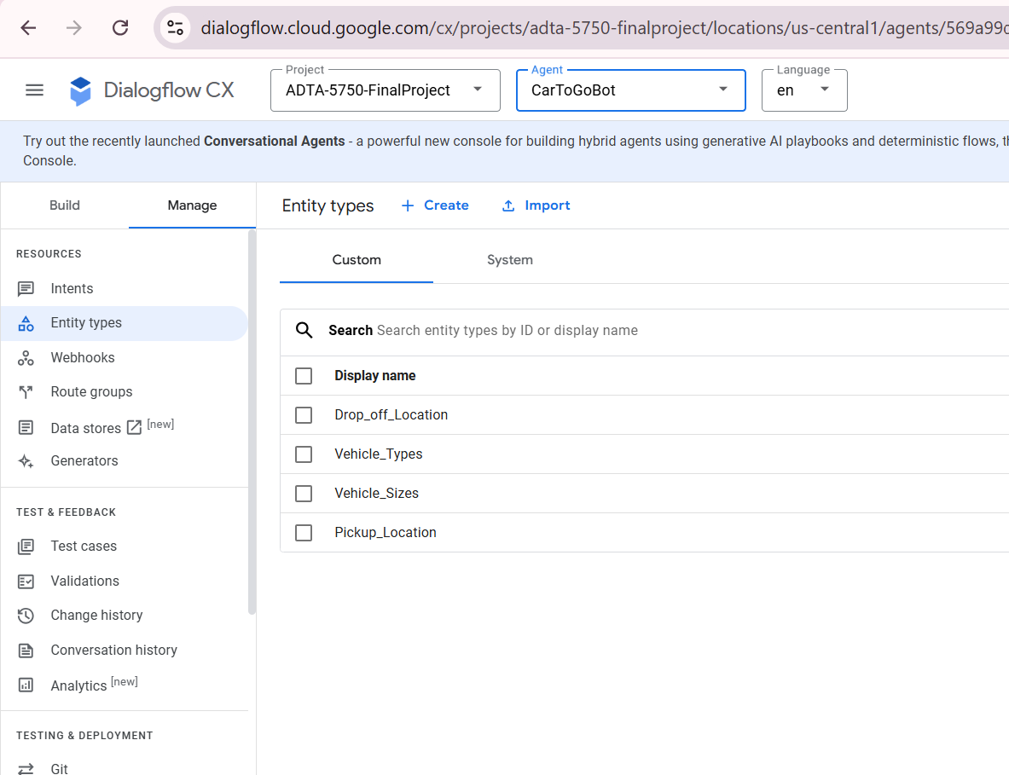
Figure: Entity Types

- Intents
  - The system has two default intents
    - default welcome intent
    - default negative intent
  - The below four intents are created for the virtual conversational agent.
    - Swap
    - Booking
    - Cancel
    - Confirm
  - The below screenshot shows the intents created for the chatbot.
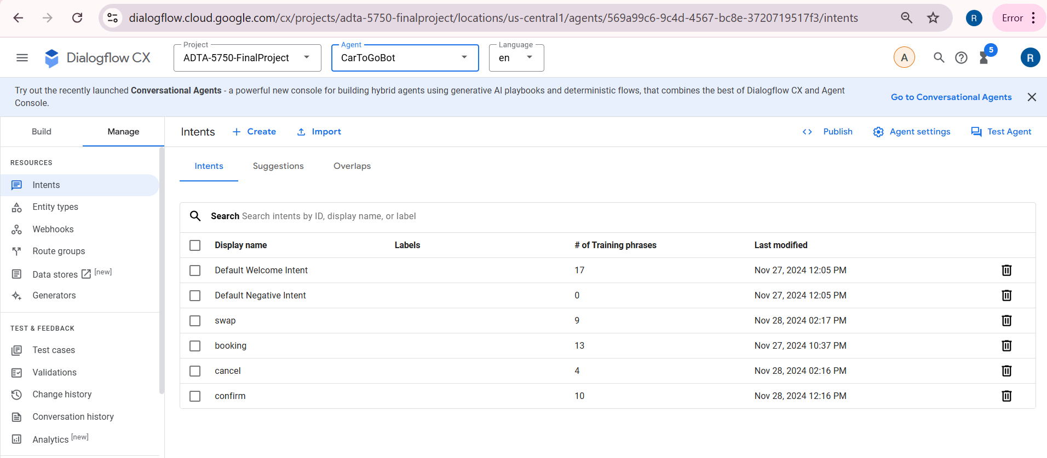
Figure: Intents
Development Process
- Tools and Technologies
  - We have used DialogFlowCX from Google Cloud Platform to build the virtual conversational agent.
- Development Methodology
  - We have used the waterfall model to build the chatbot which included the below mentioned steps.
    - Requirement Analysis: We collaborated to identify all the requirements and created a project plan to stay on track and meet deadlines
    - System Design: We created a data model, identified the intents, entities and entity types for the system.
    - Implementation: We created the components as per the requirement and design of the system.
    - Integration and Testing: We integrated the flows and added conditional responses to handle the general as well as the specific responses. We created and executed the test cases and generated the coverage report to analyse the performance of the virtual agent.
    - Deployment: We are not using any webhooks for deployment. We are using the simulator to test and verify the chatbot.
Implementation
- The below steps were taken for the implementation of the chatbot.
  - Created the Intents
  - Created Entity Types
  - Created Default Start Flow and start page
  - Created Booking Flow, the associated pages and added conditional routes.
  - Created the Cancel flow, the associated pages and added conditional routes.
  - Created the Confirm flow, the associated pages and added conditional routes.
  - Created the Swap flow, the associated pages and added conditional routes.
Conclusion
The virtual agent was implemented successfully and demonstrates the capability to manage complex conversations in the car rental booking process.
References
- Dialogflow CX Documentation: https://cloud.google.com/dialogflow/cx/docs
- GCP Official Website: https://cloud.google.com

